**DALAC**

**Workspace Management System**

**Deliverable 5**

IS 436 – Structured Systems Analysis and Design

May 14, 2018

David Luco

Amanda Ali

Luke Stigdon

Anita Sharma

Collin Sullivan



**Interface Design Prototypes**

*Prototype 1*

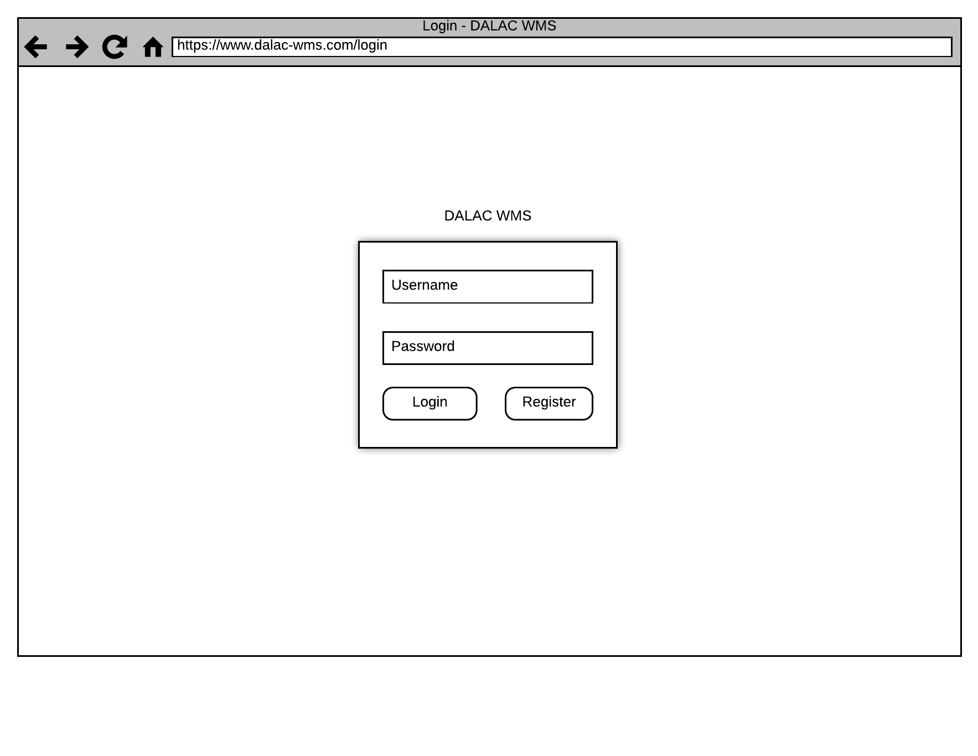

*Prototype 2*

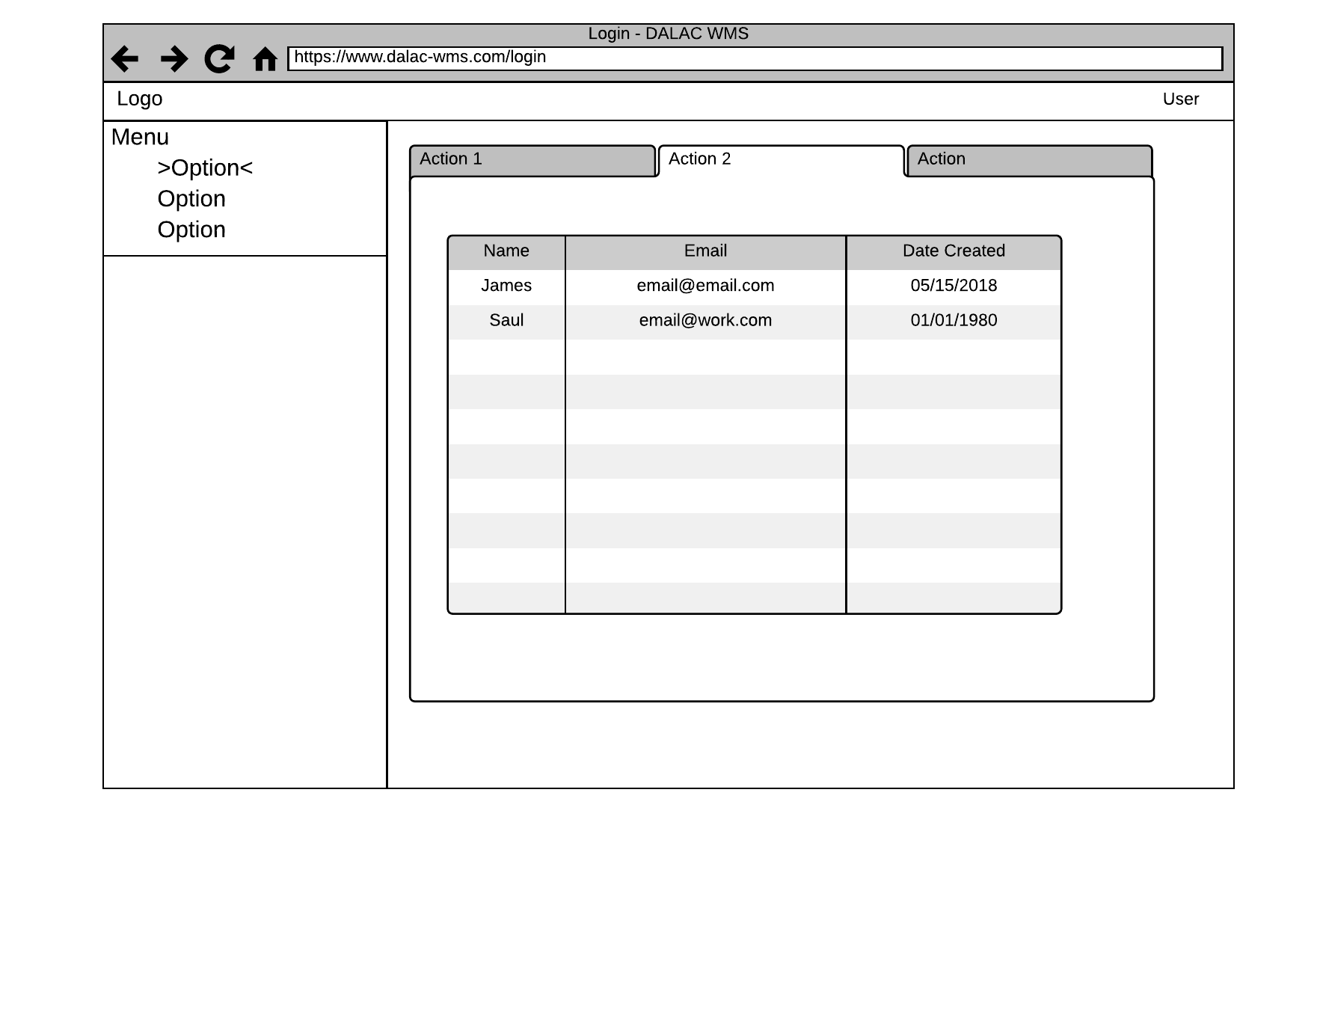

*Prototype 3*

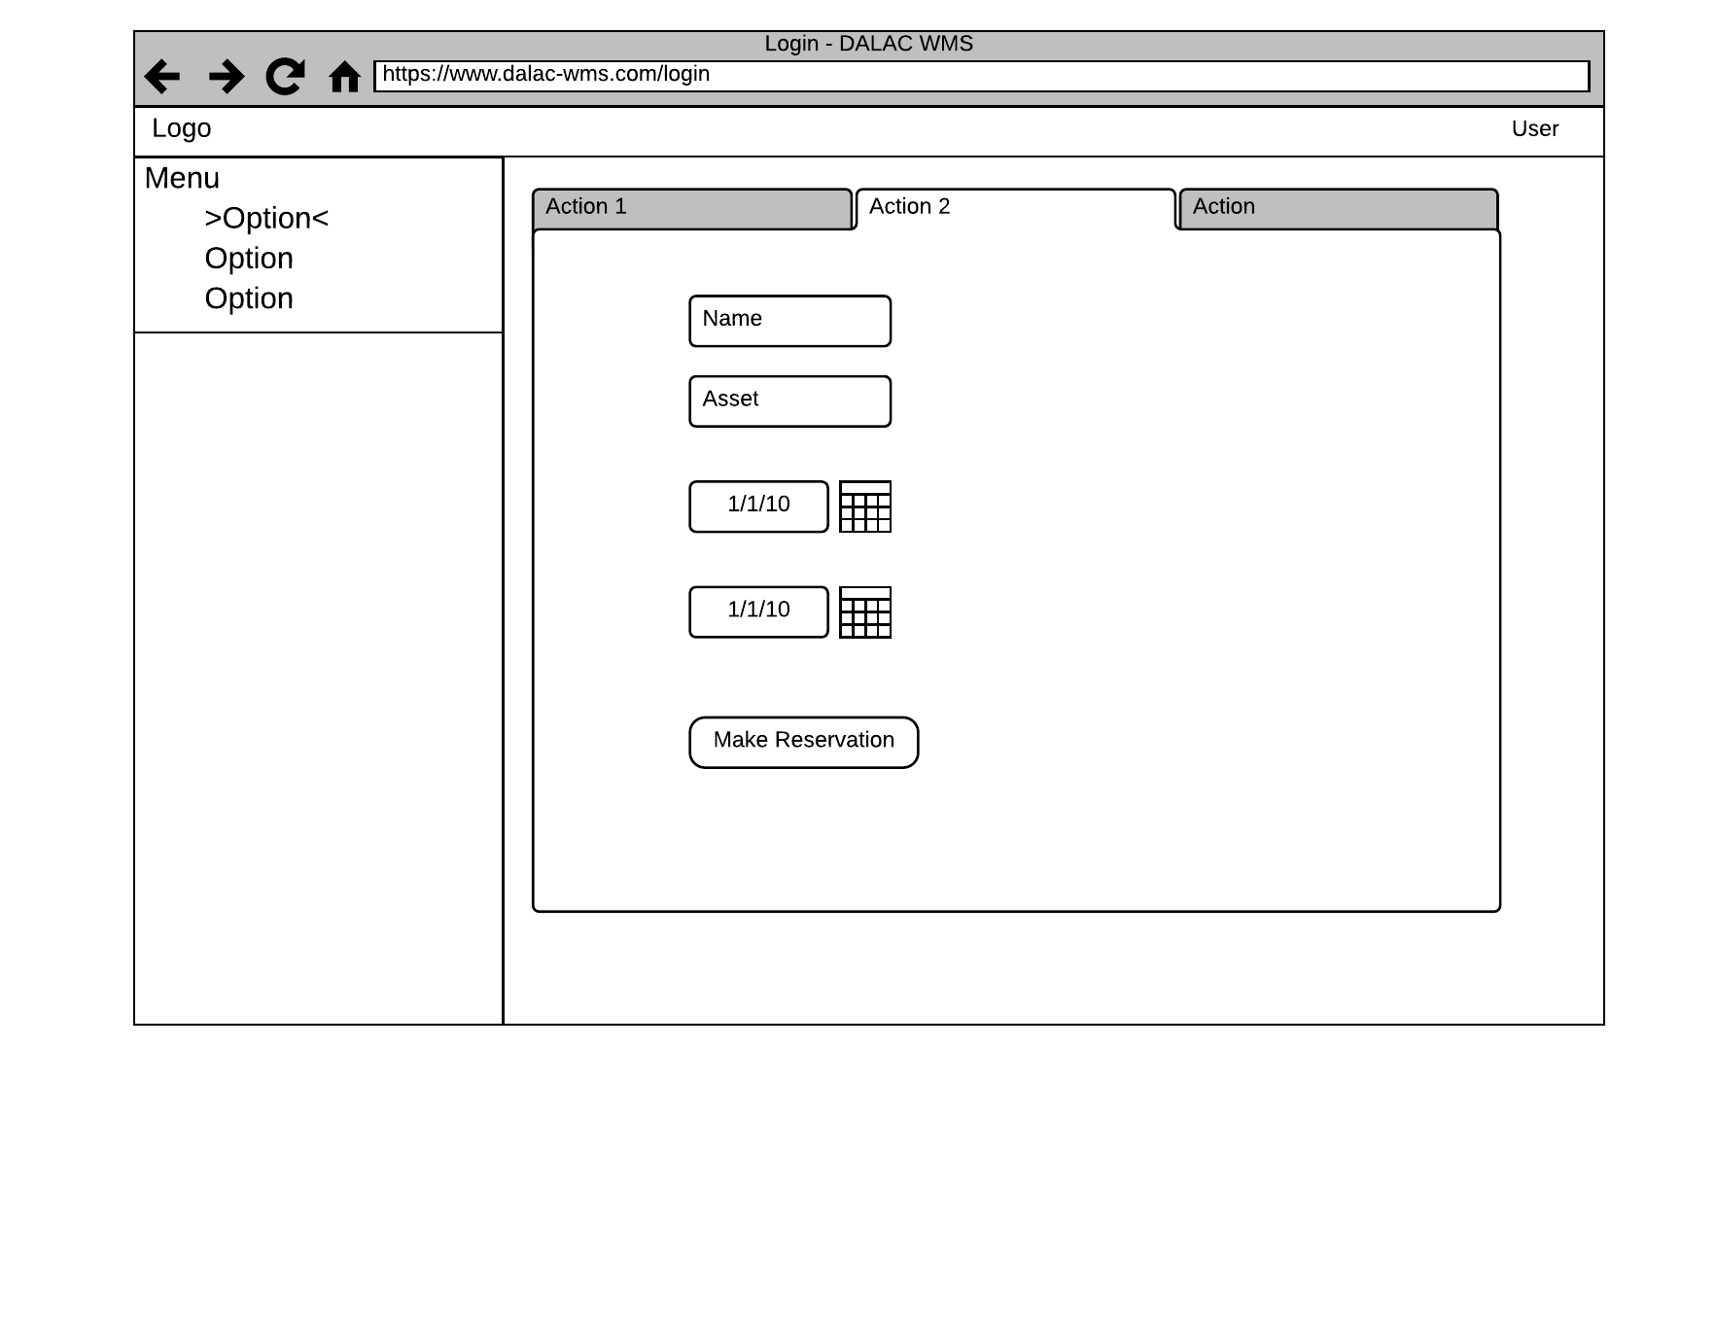

**Interface Standards**

* Maintain consistent functionality throughout the sight
* Use clean sans-serif fonts and contrasting colors to improve readability
* Build interface with a well supported front end framework (e.g. bootstrap, react, bulma)

**Program Design**

*Requirements to Implement Project*

* Based on use cases there were several key pieces of functionality were required
  + Create and delete users
  + Create and delete assets
  + Create and delete reservations
* A minimum viable product was built using PHP to test use cases and the interface standards
* The application is very lightweight and can be run on a small web server or hosted by a cloud provider at minimal cost (in some cases FREE)

**Team Experiences**

From the beginning our team thought it was challenging to have a multitude of ideas for each SDLC process and organize everything. However, we solved this problem by making sure each of us followed the kanban, our project timeline, and the requirements of each deliverable. We also learned a lot about group communication and collaboration. Whenever someone finished their tasks early, they would communicate with any other team member who needed help. Also, if any team member was unsure about how to go about a specific task, he or she would communicate with the whole group to get each person’s perspective until a decision was made. Overall the entire SDLC project gave us valuable insight as to how the process works in a real world work environment.

**Updated Project Plan**

